CS 255 System Design Document: DriverPass

Prepared by: Justin Sloane | Course: CS 255 System Analysis and Design | Date: October 18, 2026

UML Diagrams

UML Use Case Diagram
This use case diagram was created in Lucidchart in Module Six and is reused without changes. It shows the six actors that interact with the DriverPass system and what each one needs to do. The customer can register an account, select a package, log in, reset their password, take online classes and practice tests, view test progress and driver notes, contact DriverPass, and make, modify, or cancel reservations. The secretary shares the registration and reservation use cases because Liam asked that customers be able to book online or by calling or visiting the office. The driver can view their schedule and enter lesson comments. The IT admin manages user accounts, resets passwords, and blocks access for former employees. The owner downloads the activity report showing who made, modified, or canceled reservations and can disable a package. The DMV is an external actor that sends rule and policy updates. Selecting a package, taking online classes, and viewing test progress all include Login, because those features require a secure customer account.
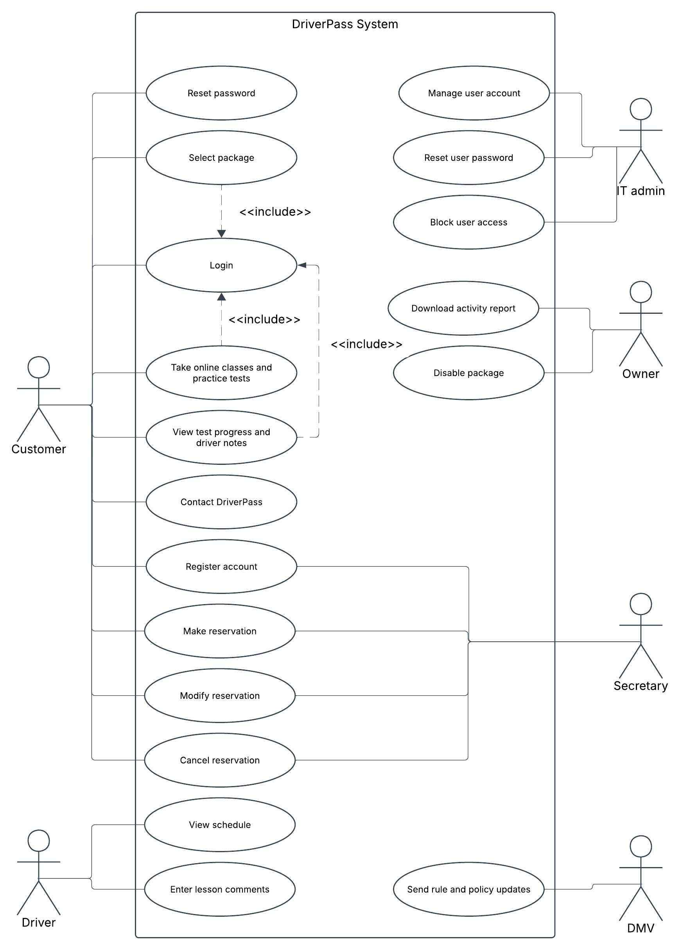
Figure 1. DriverPass use case diagram

UML Activity Diagrams
Two use cases from the diagram above, Make Reservation and Register Account/Select Package, were broken down into activity diagrams. Each diagram uses swimlanes to separate what the customer or secretary does from what the DriverPass system does, and uses decision points, a loop, and a fork/join to show steps that happen at the same time.

Activity Diagram 1: Make Reservation (Schedule a Driving Lesson)
This flow starts when a customer (online) or the secretary (by phone or in person) logs in. The system confirms the customer still has driving hours left in their package, then loops until the user picks a two-hour time slot where a driver and car are free. When the appointment is confirmed, the system saves it with the customer, driver, car, and time and, in parallel, records who made the reservation in the activity log so Liam can trace every change.
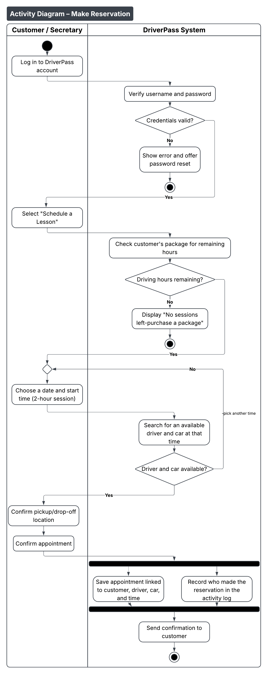
Figure 2. Activity diagram: Make Reservation

Activity Diagram 2: Register Account and Select Package
Registration can start online or with the secretary filling in the customer input form. The required information comes directly from the interview: first and last name, address, state, phone, pickup and drop-off location, and credit card number, expiration date, and security code. Only packages that Liam has left enabled are displayed. The system validates the information in a loop until it is correct, creates the account, stores the record and logs who created it, and unlocks the online class and practice tests only when Package Three is selected.
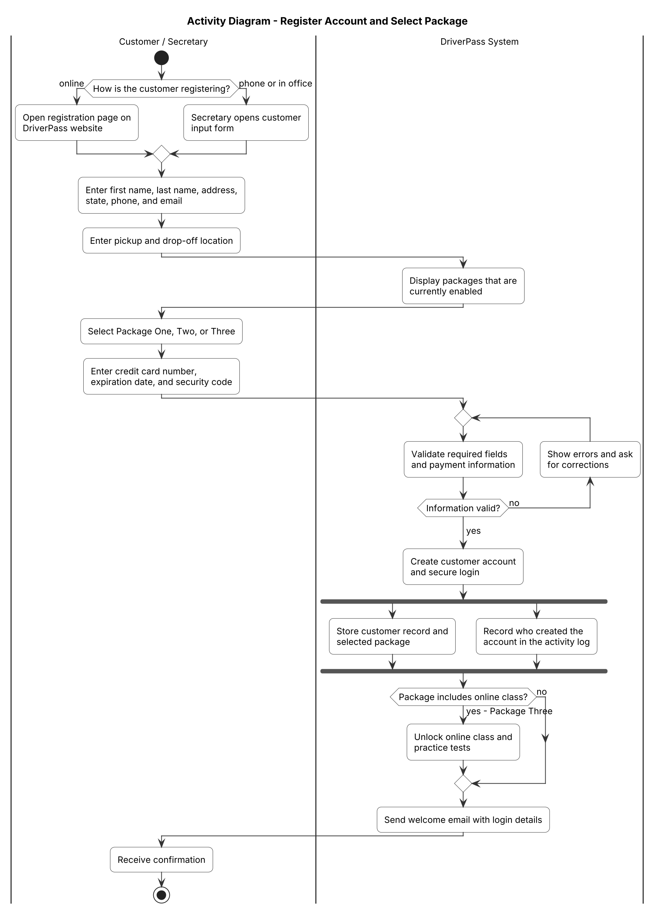
Figure 3. Activity diagram: Register Account and Select Package

UML Sequence Diagram
The sequence diagram expands the "Make Reservation" use case and shows the messages passed between objects over time. The customer interacts only with the web/mobile interface (boundary object). The scheduling controller coordinates the work: it checks remaining package hours, searches for an available driver and car, saves the appointment, and writes an entry to the activity log. Two nested "alt" fragments show the alternate outcomes when the customer has no hours left or when no driver and car are available at the requested time.
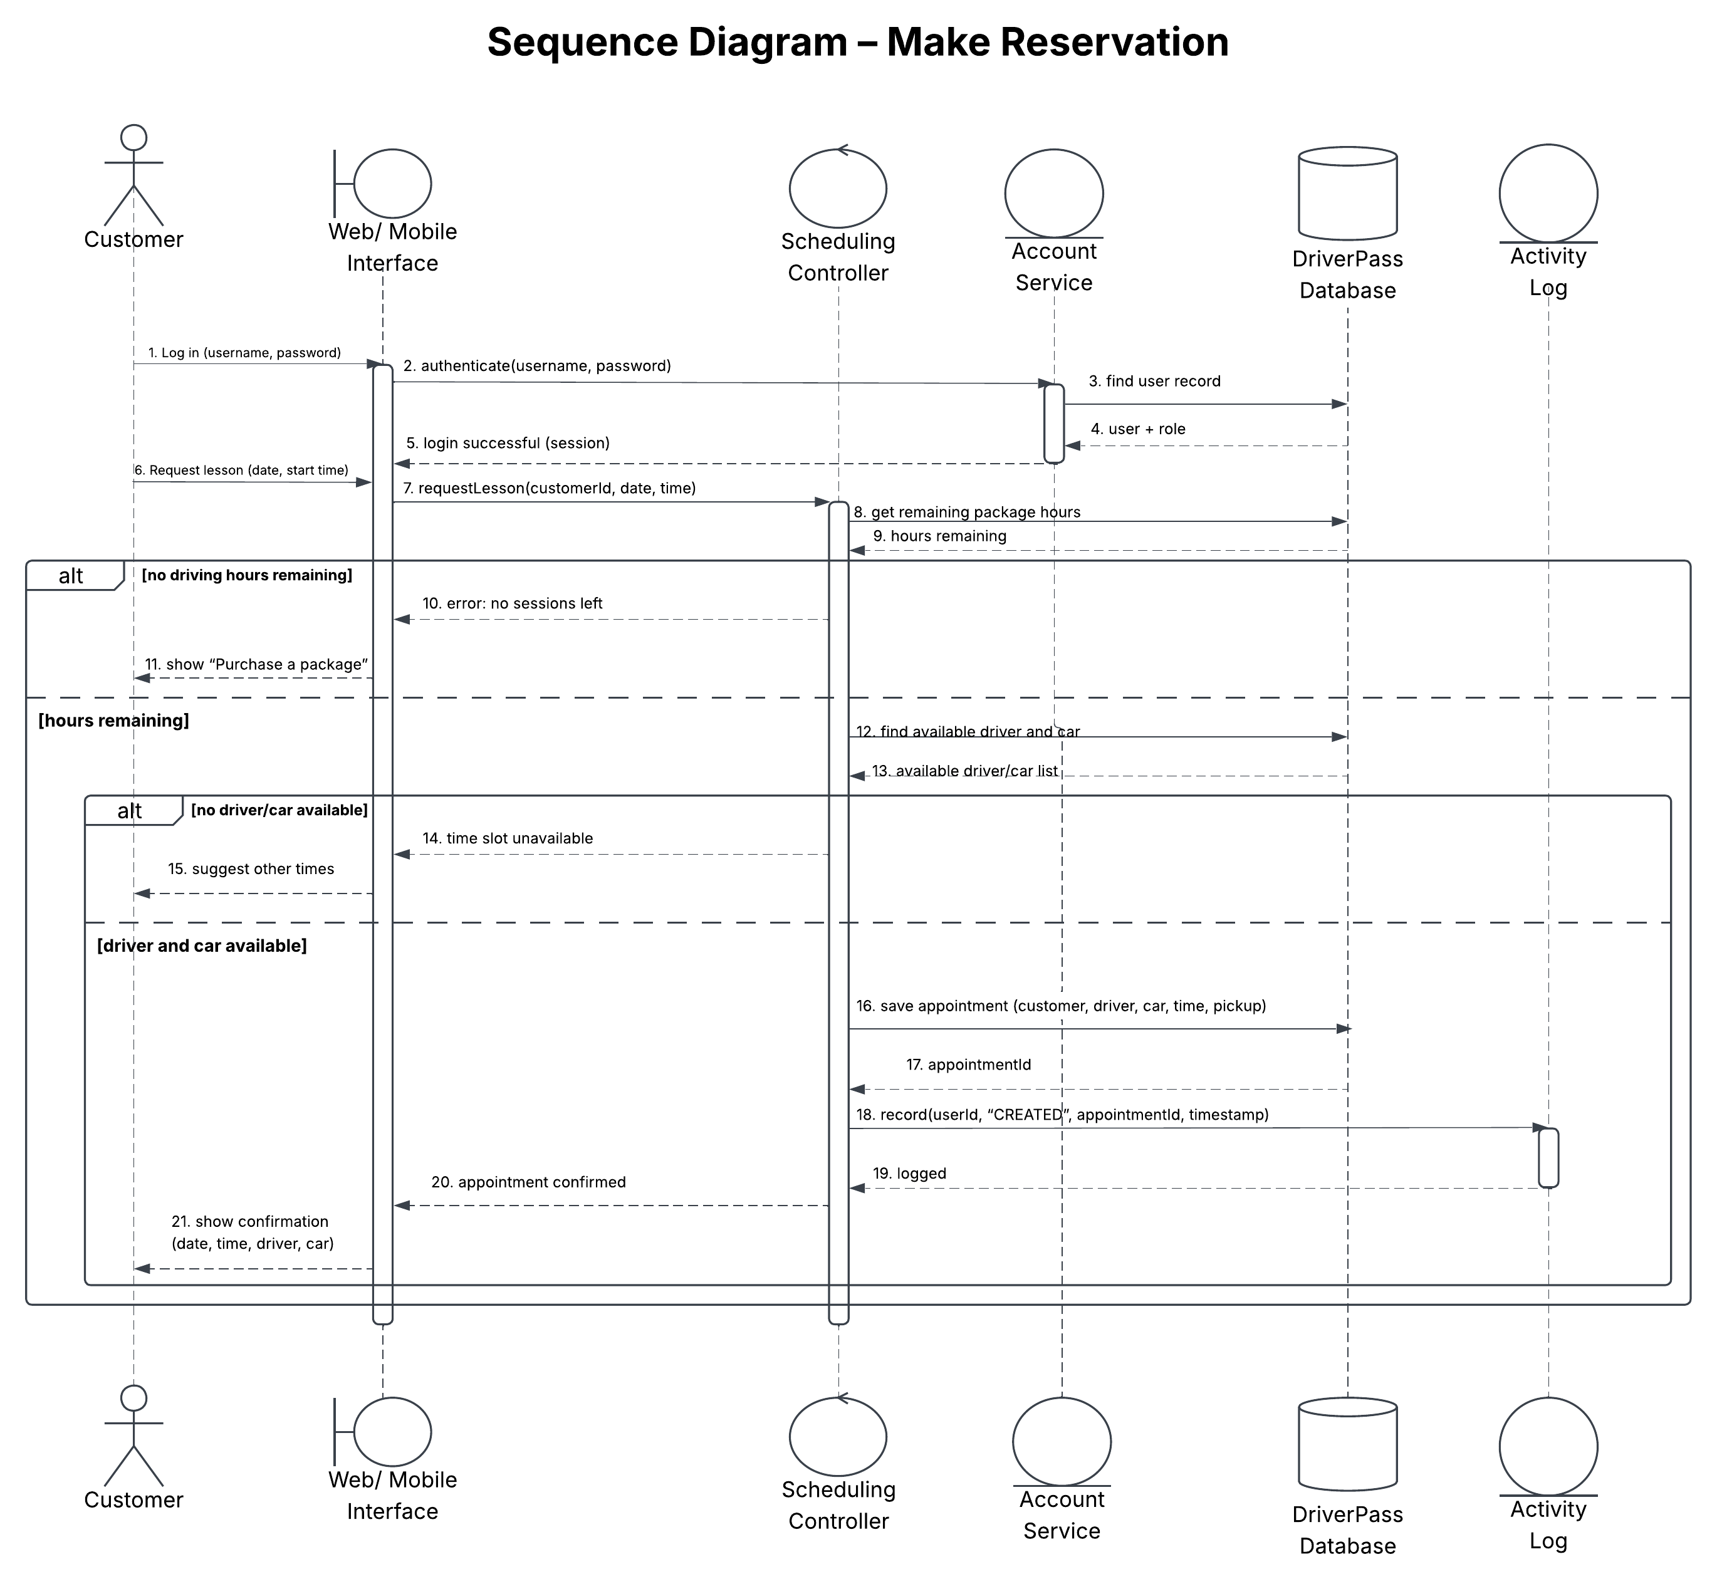
Figure 4. Sequence diagram: Make Reservation

UML Class Diagram
The class diagram shows the classes, attributes, and relationships needed to build DriverPass. An abstract User class holds the login information and role shared by everyone; Customer and Employee inherit from it, and Driver inherits from Employee. A Customer purchases Packages through an Enrollment (which tracks hours remaining), books Appointments, and takes TestAttempts whose status is Not Taken, In Progress, Failed, or Passed, matching Liam's sketch. Each Appointment links one Driver and one Car and can contain a DriverNote with the lesson time, start and end hour, and comments. Composition (filled diamond) is used where a part cannot exist without its whole, such as PaymentInfo and DriverNote. ActivityLog records the user, action, and time of every change; DMVUpdate stores notifications from the DMV; and Package.isEnabled lets Liam disable a package without deleting it. Enumerations define the allowed roles and statuses.
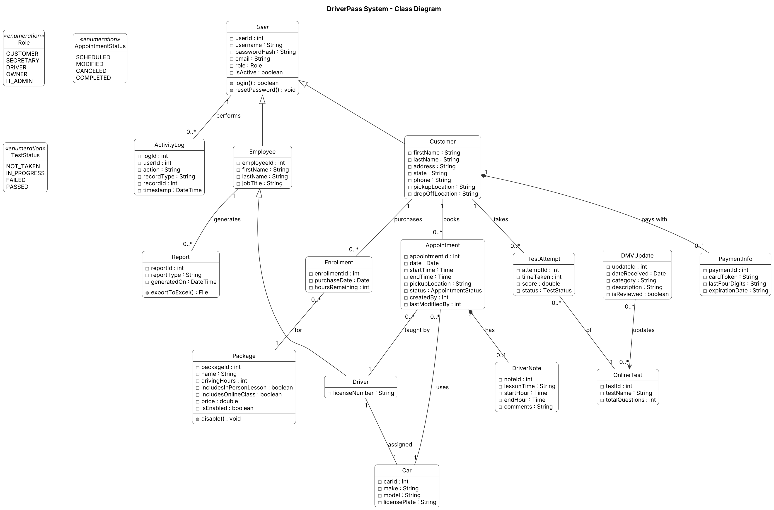
Figure 5. DriverPass class diagram

Technical Requirements
The technical requirements below are based on the functional and nonfunctional requirements gathered in Project One and on the design shown in the diagrams above. Ian asked that the system run on the web, preferably in the cloud, so that DriverPass does not have to manage its own backups or security. The design therefore uses a cloud-hosted, web-based architecture with a three-layer structure: the interface, the business logic, and the database.

Hardware
• Client devices: Any desktop, laptop, tablet, or smartphone with a modern web browser (Chrome, Edge, Safari, or Firefox) and an internet connection. Liam needs to access data from any computer or mobile device, so no special hardware is required for customers or staff.
• Office equipment: Standard computers and a printer for the secretary and owner so that phone and walk-in registrations can be entered and activity reports can be printed.
• Servers: No on-site servers. All application and database servers are virtual machines provided by the cloud host (for example, AWS, Microsoft Azure, or Google Cloud), which can scale up during busy periods and scale back down to control cost.

Software
• Front end: A responsive web application built with HTML5, CSS3, and JavaScript (for example, using React) so pages adjust to phone, tablet, and desktop screens. Pages include the customer input form, scheduling calendar, online test progress table (test name, time taken, score, status), driver notes table, contact page, and reports.
• Back end: An application server built with a mainstream framework such as Java Spring Boot, ASP.NET, or Node.js. This layer contains the business logic shown in the sequence diagram: authentication, role-based permissions, scheduling and driver/car matching, package rules, and activity logging.
• Database: A relational database such as MySQL, PostgreSQL, or a managed cloud equivalent. Tables map to the classes in the class diagram (User, Customer, Package, Enrollment, Appointment, Driver, Car, DriverNote, TestAttempt, OnlineTest, ActivityLog, DMVUpdate). Primary and foreign keys enforce the relationships, and a single central database prevents the duplicate data Sam warned about.
• Reporting: Reports and the activity log can be viewed online and exported as Excel (.xlsx) or CSV files so Liam can work on them at home. Downloaded reports are read-only copies; data can only be changed while online.
• Integrations: A connection to the DMV (web service/API or secure feed) that delivers new rules, policies, and sample questions and triggers a notification to the owner and IT officer. A PCI DSS-compliant payment processor (for example, Stripe or Square) handles credit card transactions, so full card numbers and security codes are never stored by DriverPass. An email service sends confirmations and automatic password-reset links.

Tools
• Design and modeling: Lucidchart (CASE tool) for UML use case, activity, sequence, and class diagrams.
• Development: An IDE such as Visual Studio Code, IntelliJ IDEA, or Eclipse; Git with GitHub for version control; and a project tracker such as Jira to follow the schedule from requirements through sign-off.
• Testing and deployment: Automated unit and integration tests, plus a continuous integration pipeline that tests and deploys new releases to the cloud. Browser testing on desktop and mobile devices.

Infrastructure
• Cloud hosting: The application and database run with a cloud provider that handles physical security, automatic backups, patching, and redundancy, as Ian requested. Target availability is 99.9% so customers can book lessons at any time.
• Network and security: All traffic is encrypted with HTTPS/TLS, and data at rest is encrypted. Passwords are stored as salted hashes. Role-based access control limits what each user can do: customers see only their own records, the secretary manages appointments, drivers enter notes, the owner views reports, and the IT officer has full account control to reset passwords or block former employees. A firewall and lockout after repeated failed logins protect against attacks.
• Backup and recovery: Automated daily backups with point-in-time recovery, stored in a separate cloud region, so data can be restored if something goes wrong.
• Auditing: Every create, modify, and cancel action is written to the activity log with the user, date, and time, which supports Liam's requirement to know who is responsible for every reservation change.
• Scalability and flexibility: Packages are stored as data with an enabled/disabled flag, so Liam can stop new registrations for a package without a developer. Adding entirely new package types or modules is planned for a future release.

